2/15/2023

Dalton Walls

**SPRINT REVIEW AND RETROSPECTIVE**

Congratulations team, we made it through the SNHU Travel Project successfully and it’s time for our review and retrospective. As you know we do this after every project in order to summarize the project as well as analyze our team’s performance on it. As usual, we want to learn something that can make us better in the future.

First of all, we have to recognize our Product Owner’s efforts here. From the very start they were responsible for setting up the meeting between the scrum team and SNHU Travel. They also acted as facilitator during this meeting, making sure that communication stayed open and clear and that both the client and the scrum team knew exactly what was going on. Things went great from the start and this open communication allowed us to see SNHU Travel’s vision for their new booking system. Furthermore, they continued to provide valuable work with keeping in communication with the client during the project, as evidenced by the agile pivot we had to make in the latter half of the work. Without the Product Owner’s ongoing communication with them, we wouldn’t have known that the client wanted to pivot into detox and wellness retreats.

Next, we have the Dev Team. Great job guys. I see that everyone was always working on something and that several of you learned new programming skills along the way. This makes us a stronger team for future projects. One of the ways we accomplished this was by pairing programmers together so that they could learn from each other as well as have two sets of eyes on the coding.

Working in tandem with the Dev Team were the Testers. I see that you guys were able to communicate closely with the Dev Team about what aspects of the project needed tested but you also went above and beyond by designing these tests together to make sure they were extra efficient. Great job.

We continued with our Agile approach during this project and it is safe to say that we are seeing continued success with this method. For instance, we were able to successfully implement each of our user stories into features for the booking system. From being able to see a top list of the hottest vacation spots to having those spots personalized for SNHU Travel’s users, we accomplished a lot. One specific user story that we accomplished through Agile was “I want to be able to see a list of the top detox and wellness retreats”, which wouldn’t have been possible in a traditional approach due to the fact that it was a requirement that came to us halfway through the project.

Communication was key during this project and I want to review an example of a communication between our team:

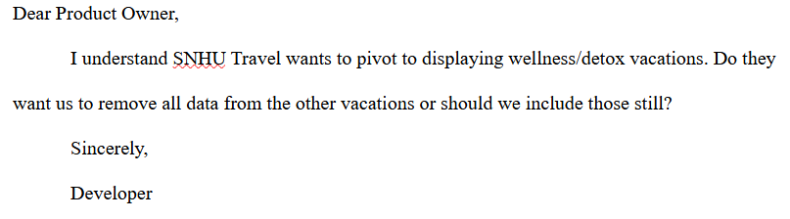As you can see here in this example, we have a communication from a member of the Dev Team to the Product Owner. What was great about this communication is that the Developer asked a question to make sure that they were on the right track instead of just guessing. Great job here, there are no dumb questions, and it takes courage to ask them. We also have to commend the Product Owner as I understand that they did get back to the Developer and resolved this inquiry.

I see that we used Azure Boards as an organizational tool during this project. This acted not only as an Information Radiator but also as our Product Backlog and Kanban Board. I think we will continue to use this in the future after seeing how well we all took to it.